ALL SERV ICES AND MEETINGS IN OUR FACILITIES ARE CANCELLED UNTIL FURTHER NOTICE.
NOTE: JOIN OUR RECORDED OR ONLINE SERVICES ON OUR WEB PAGE BELOW:
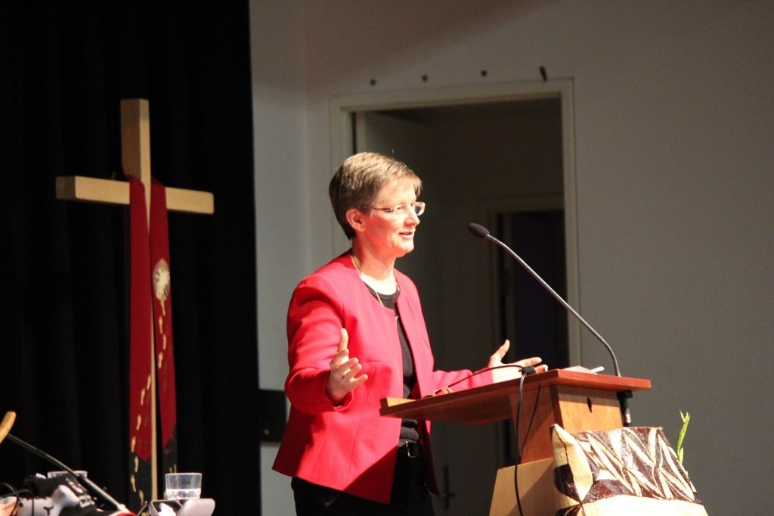
Minister
Rev Kath Merrifield 0409 650 118
revkath@ozemail.com.au

Pastoral Convenor
Rhonda Back 0400 980 977
bathers71@optusnet.com.au

Email for Newsletter articles kiamauc.notices@gmail.com

Website Kiama-jamberoo.unitingchurch.org.au
Facebook www.com/kiamajamberoo.unitingchurch/

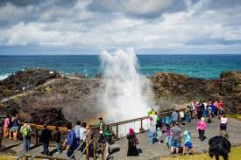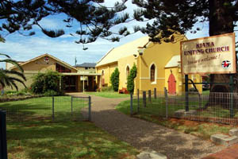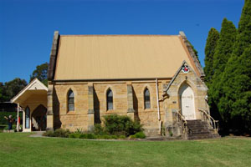

Kiama Jamberoo Uniting Church
Sunday, 24 May 2020
Postal Address: PO Box 140 Kiama 2533

MESSAGE FROM REV KATH MERRIFIELD
Sunday 10.30am Morning Tea by Zoom
The link to connect via your computer or device is sent out by email each week with the Worship materials. Please let Kath know if you would like to try joining by phone. We would love to see you or to hear your voice on the line!

Healing Service
The Healing Service for May is currently being prepared by Rev Janice Freeston and will be available during the week. Keep an eye on Facebook and the website. Please send the link on to any of your friends and family who might appreciate some quieter time for reflection.

Ipad / Computer help
Would you like help with using your iPad or computer? Then let Kath know (phone or email). There are a number of people willing to help out. We can either organise a time to meet at the church or we can come to your home (appropriately physically distanced) and help get you connected.

COVID-19 Update from Synod of NSW/ACT
While restrictions across the community are beginning to be relaxed, the advice from Synod is that we should not be meeting face-to-face in a large group for the time being. The latest update and guidelines from the Synod are attached for your information and to help you if you are having conversations with people who normally attend any of the many groups who meet in our facilities. Please continue to be in touch with one another by phone and email etc, or you could meet with another person and go for a walk or a physically distanced coffee. Please continue to keep a listening ear open for anyone who might be struggling.

Sunday 31 May - PENTECOST
Pentecost is the celebration of the Holy Spirit coming to the disciples (Acts 2). You might like to think about how the Spirit is moving in your life. Have you been creative during this time of isolation? Where have you seen God at work? Could you share your answers by taking a photo or a short video or send something descriptive that we can share during worship? It would be great to have your responses by the end of Thursday 28 May.
And you might also like to wear something red to morning tea that day.

PRAYERS OF THANKSGIVING AND INTERCESSION IN THE TIME OF CORONA VIRUS

For the health workers tending the seriously ill
for the scientists working on a vaccination
for the researchers analysing data and identifying trends
for the media outlets working to communicate reality
for the supermarket workers, hygiene and sanitation providers
for the good news stories of recoveries and effective planning
for the singing from balconies by locked-down communities
for the recognition that isolation doesn’t need to mean loneliness
for the notes through letterboxes offering help and support
for the internet and telephones and technology that connects
for the awakened appreciation of what is truly important
Thanks be to God.

For those who are unwell and concerned for loved ones
for those who were already very anxious
for those immune suppressed or compromised
for those vulnerable because of underlying conditions
for those in the ‘most at risk to coronavirus’ categories
for those watching their entire income stream dry up
for those who have no choice but to go out to work
for those who are afraid to be at home
for those who are more lonely than they've ever been
for those who are bereaved and grieving.
God be their healer, comfort and protection,
be their strength, shield and provision
be their security, safety and close companion

And raise up your Church
to be your well-washed hands and faithful feet
to be present to the pain
to respond with love in action
if even from a safe distance.

God, in your mercy,
Hear our prayer.

FOCUS FAMILIES
Rhonda and Daryl Back Kathryn Reed
David and Eileen Radford Alan and Shirley Rowe
Marion and Reuben Rattray Stephanie & Travice Pryor

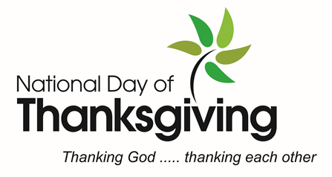

Saturday 30 May 2020

